Live Score Page Design

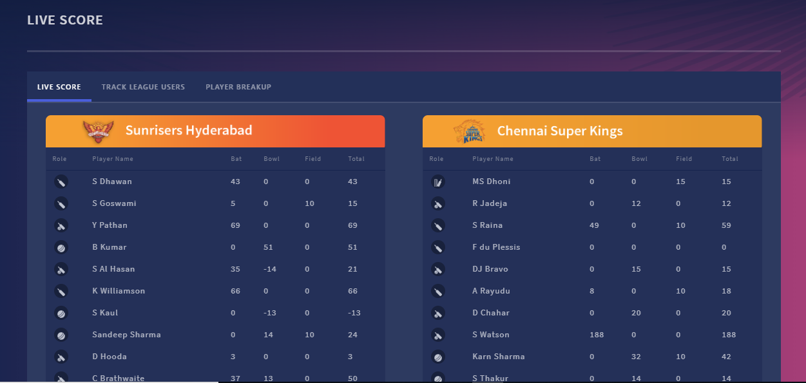

1st Tab: Live View(need first two tabs, last tab is not required)

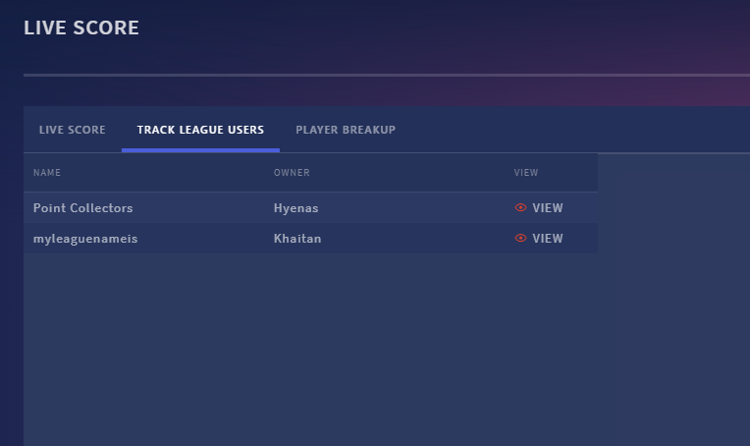
2nd Tab: Live League Users

- First Tab will name “Live View” as above and it should display currently played Match player statistics(Type, Name, Bat, Bowl, Field, Total points) using below API,
http://fanzania.com/FantasyCricketRest/api/fantasycricket/live-tournament-details

http://ec2-52-207-99-56.compute-1.amazonaws.com/FantasyCricketRest/api/fantasycricket/live-match-score

If there are multiple matches live at the same time, it will list down Match1, Match2 as tab under Live Score: This list of matches will be retrieved using below API:
http://ec2-52-207-99-56.compute-1.amazonaws.com/FantasyCricketRest/api/fantasycricket/live-matches

If there is no current match going on, it should not display anything.

- Second tab will name “Live League Users”, which will display League name(if there are multiple leagues for any user). Then user has to select which league users wants to view(Eye). If there is only one league for that user, then it will directly go inside that League page with Users live score at that moment. League Page will display “User”, “Team”, “Live Position(with up/down arrow)”, “Live Points”, “View(Eye)”. When User clicks on View for any Team, it will display like “Live View” page(as pop up) with that users player details(Type, Name, Bat, Bowl, Field, Total Points). Below three APIs will be required for this page,

To display all leagues under that user:
http://ec2-52-207-99-56.compute-1.amazonaws.com/FantasyCricketRest/api/fantasycricket/user-all-leagues

To display particular league users with live points:
http://ec2-52-207-99-56.compute-1.amazonaws.com/FantasyCricketRest/api/fantasycricket/live-league-users

To display player live score for a given user Team:
http://ec2-52-207-99-56.compute-1.amazonaws.com/FantasyCricketRest/api/fantasycricket/live-user-team-score

All live score pages will be view only. And there will be “refresh” circle

in each page to refresh the page(user has to click on it) to fetch latest score points.

